**Mining guild escape 1**

(hyperdrive broken (8 turns till repaired), enemy territory, 14 turn counter, 1 debris in player deployment zone + 6 random asteroids, recommended players 3, rank F)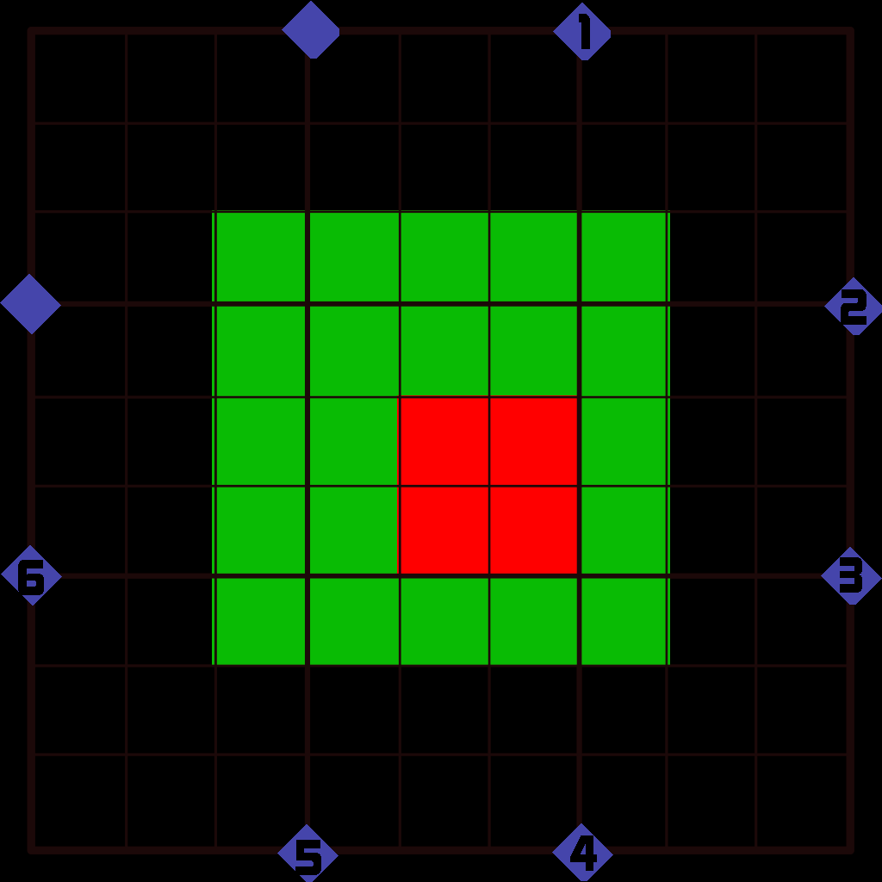

Light red: Friendly Deployment Zone

Green: Obstacle Placement Area

Enemies:

Start: h4 mining guild TIE

h5 mining guild TIE

R3: hD6 mining guild TIEx2

R7: hD6 mining guild TIEx2

R9: hD6 mining guild TIEx2

hD6 mining guild TIE

Goal: Escape

Payout:

Standard (in stolen goods(tibanna gas))

**Spectacle Fight**

(friendly territory, 10 turn counter, 10 debris and 3 asteroids, recommended players Any, rank Variable, players fly in random rental ships of the same Tier as the Rank of mission)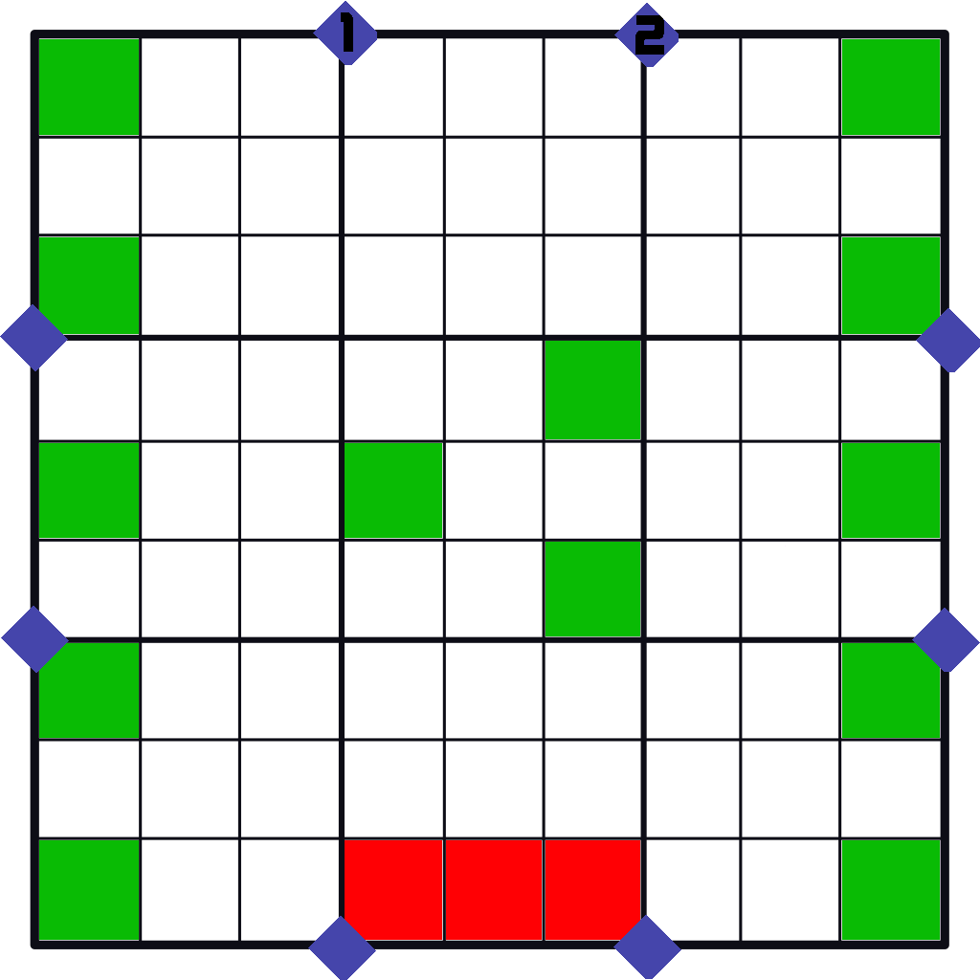

Light red: Friendly Deployment Zone

Green: Obstacle Placement Area

After running, becomes Available again after 3 missions with next tier unlocked

Enemies:

Start: hD2 random ship of the same Tier as the mission’s Rank(standard initiative)

Repeat above for each player beyond the first

Goal: Survive

Payout:

Cowardice will not be tolerated, escape = 0 pay

½ Standard

¼ base price of each ship destroyed

Survival bonus

Base ship price Payout

800-1000 800cr

1000-1200 400cr

1200-1400 200cr

1400-1600 100cr

1600-1800 50cr

1800-2000 25cr

2000+ 0cr

**Escape with Tibanna Gas**

(Hyperdrive disabled, enemy territory, 10 turn counter, 18 random asteroids, recommended players 2, rank F)

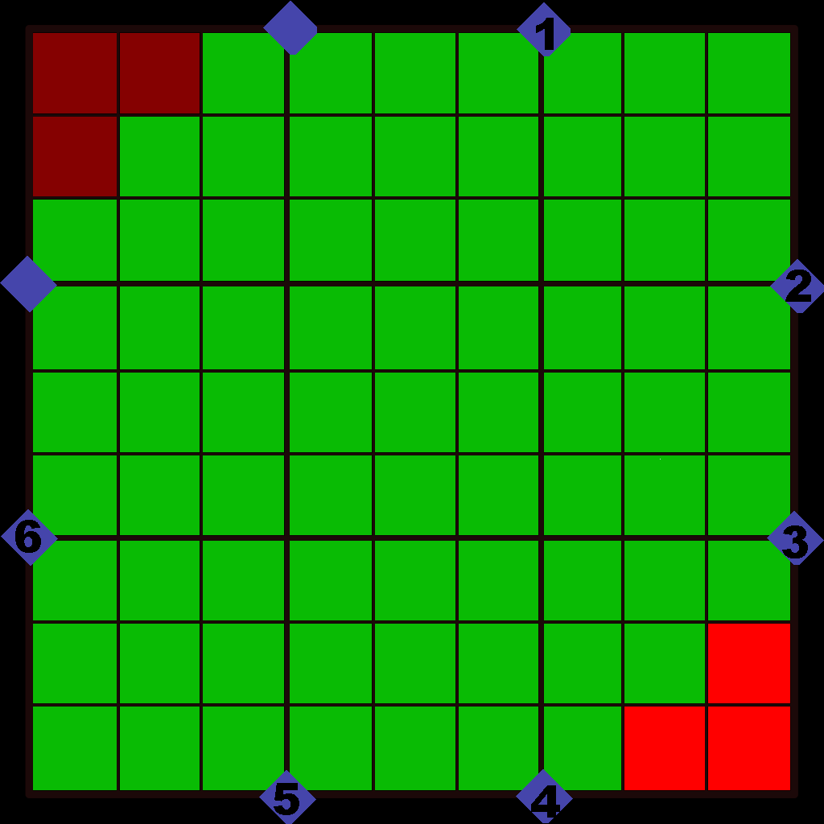

Light red: Friendly Deployment Zone

Dark red: Friendly Escape Edge

Green: Obstacle Placement Area

Enemies:

Round 1: hD6 mining guild TIE (After friendly forces placed)

hD6 mining guild TIE (After friendly forces placed)

Each round after: hD6 mining guild TIE

Goal: Escape

Payout:

2exp to each player

Bonus 1exp to each escapee

1000cr per escapee (in stolen goods(tibanna gas))

Bonus: 100cr per undamaged escapee